Chapter – 3 DC motors and its control

3.1 A prototype DC machine

Let us consider the single rectangular loop of conducting wire as shown in Fig. 1a. It has got an area of A and is rotated in a uniform magnetic field of flux-density B. For the purpose of supplying currents to an external load, the ends of the coils are connected to slip-rings. The slip-rings are contacted by brushes. The copper wires from the brushes goes to outside to form the terminals of the generator in which load is connected. Brushes are usually spring loaded blocks of graphite that form low-resistance contact with slip-rings. The slip-rings are made up of brass or hardened copper. Graphites are soft and produces relatively little wear in the slip rings.
If the coil is at an angle, θ, to the field, its area normal to B is Asinθ and the emf is
E= dφ/dt = BA d(sinθ)/dt = B A ω d(sinθ)/dθ = B A ω cosθ

The emf produced by the rotating coil is sinusoidal, reaching its maximum value of B Aω at θ = 0⁰ i.e. when B lies in the plane of the coil and falling to zero at θ = 90⁰ i.e. when B is normal to the plane of the coil. So this simple machine is an AC generator.
The output voltage across the terminals of the generator is alternating in nature. To get DC output it is necessary to provide commutation in the form of split slip-rings as shown in Fig. 1b.
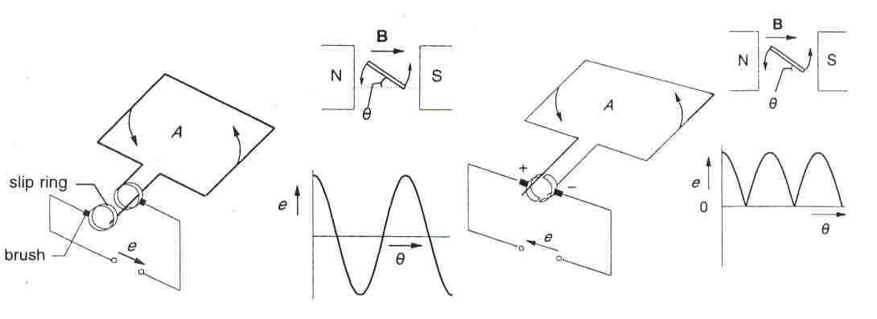

Fig. 1a A simple generator Fig. 1b Split slip-ring commutator

During rotation while the current in the coil A will reverse, the brush breaks contact with one split ring and makes contact with the other. This way it makes the voltage unidirectional as shown in the waveforms in Fig. 1b. The total emf of the generator though unidirectional is sinusoidal and varies in magnitude from zero to a maximum of BAω.

  - Practical DC machine

The voltage waveform in Fig. 1b even though unidirectional but it is sinusoidal in nature. A practical generator should have the output voltage constant in magnitude. One way to achieve this is to have a constant field distribution. Fig. 2a shows an arrangement of a shaded pole pieces which produces almost constant flux density in the airgap and Fig. 2b is the corresponding emf waveform.

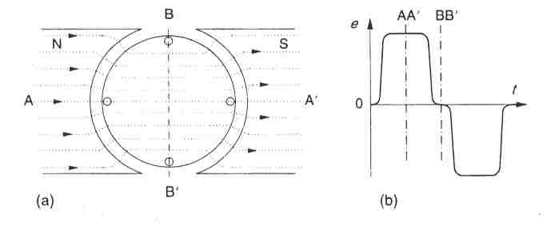

Fig. 2 Pole shape and field distribution

Another way of reducing the ripples in the voltage waveforms is to increase the number of coils in series and increasing number of poles. Usually the magnetic fields can be of two types: permanent magnet type and electromagnet type. The poles always in pair of N and S poles are held in place by a steel cylinder which also forms the outer case or stator of the DC machines. The coils are placed in the slots evenly distributed along the periphery of the rotor and is known as armature. A typical arrangement of the coil placed in a slot is shown in Fig. 3. The ends of the coils are terminated at the commutators. Fig. 4 shows a typical schematic of a 4-pole, 12-slot DC generator. Fig. 5a shows the pole winding and Fig. 5b shows the conductor in the armature slot which can be open or semi-closed.

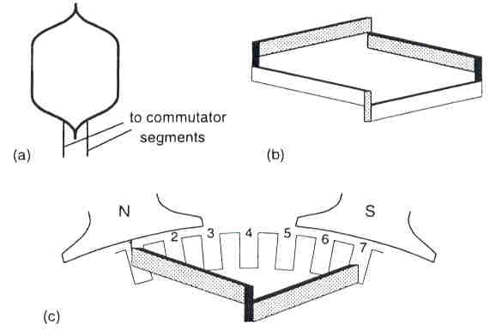

Fig. 3 View of a coil in a slot in DC machine
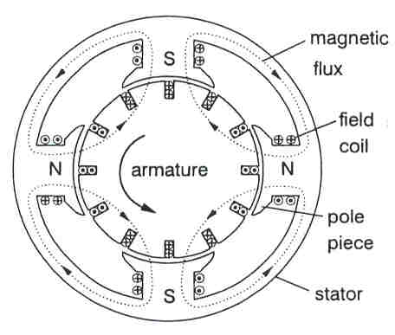

Fig. 4 A 4-pole, 12-slot Dc generator

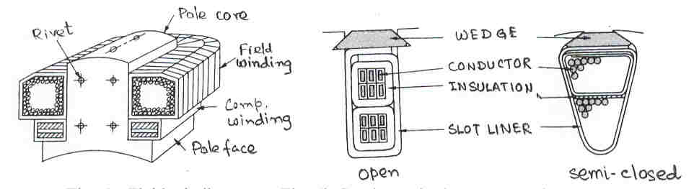

Fig. 5a Field winding Fig. 5b Conductor in the armature slot

  - Type of excitation of DC machine

Usually the field winding is supplied from a source to provide the necessary excitation in the machine. Depending on the connection of the field winding and the armature winding there can be different types of excitation possible in DC machines. Fig. 6 shows the picture of different types of excitation of DC machines. They are (a) Separately excited, (b) Shunt excited, (c) Series excited, (d) Short-s-hunt compound excitation and (e) long-shunt compound excitation. The characteristics of different types of machines will be different.

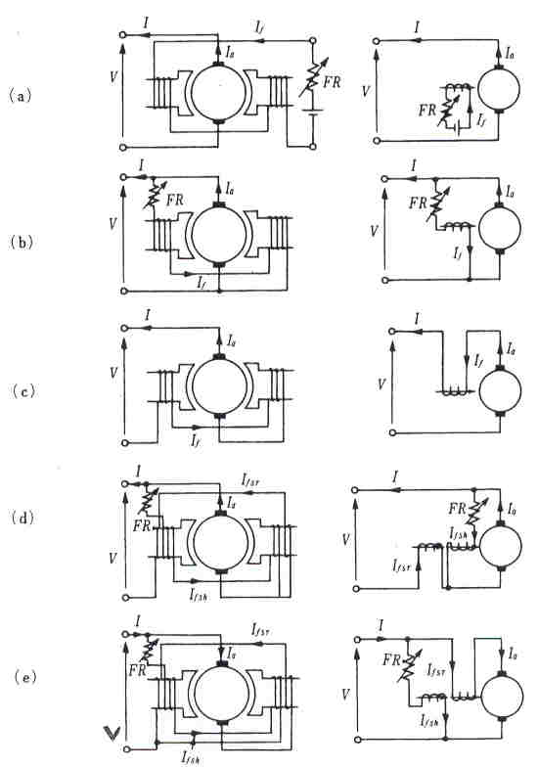

Fig. 6 Types of excitation in DC machines

  - Equation of induced emf and torque

In this section we will discuss the general expression of induced emf in a DC machine. Let us assume
P – the number of poles on a DC machine
φ – the flux per pole

Z – the total number of conductors
N – the speed of the machine in rps
a – the number of parallel path of the armature winding.
The number of parallel path depends on the type of winding. For lap winding a = P and for wave winding a = 2.

In one revolution the armature conductor cuts Pφ amount of flux. The time taken for one revolution is 1/N. So the induced emf is
e= 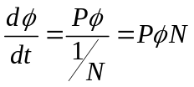
Now Z/a no. of conductors are connected in series. So the total emf in the machines is given by
E = PφNZ/a

Expressing the speed in ω rad.sec where ω = 2πN, we get

E = PφZω/(2πa) = K_{a} φω where K_{a} = PZ/(2πa) is a constant.

Usually the rotor of the DC motor is coupled to a load. The conductors on the armature cut the magnetic field and the emf is induced in it. This emf opposes the supply voltage and is called the back emf. When the armature conductor caries current a torque is developed which is delivered to the load. In this section we will derive the expression of the torque.
From Fleming’s left-hand rule we know that the force developed in a conductor of length l, carrying a current i, placed in a magnetic field of flux density B is
F = Bil
The machine has got Z no of conductor and the diameter of the machine is D. The armature current is I_{a}.
The current in each conductor is i = I_{a}/a where a is the no of parallel paths.
The force at diametrically two opposite sides at a distance D will constitute a torque.
So the total torque T = (Z/2) * F*D
The flux density B is related to the total flux Pφ of the machine B = Pφ/(πDl)
So, 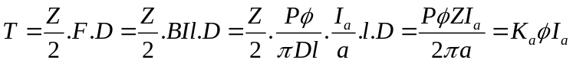.
So T = K_{a} φ I_{a}

If the speed of the machine N is given in rpm then in the EMF equation N should be replaced by (N/60).
If the supply voltage for the motor is V, the equation of the supply voltage and the emf is given by
V = E + I_{a} R_{a}.
Where R_{a} is the resistance of the armature and I_{a} is the current flowing in the armature. The above equation is true for a shunt-type motor. For other type of field equation the equation is to be modified.

3.5 DC Motor

From the construction point of view a DC motor is exactly similar to that of DC generator. But from the operation point of view it does not need any prime-mover rather it will act as a prime-mover. Usually the mechanical load is coupled to its shaft and the motor is used to rotate it. A DC supply is required to supply electric power to the motor. Different electric power supplies can be used for the field and the armature as shown in Fig. 7a but in most cases the same supply is used for the armature and the field as shown in Fig. 7b.
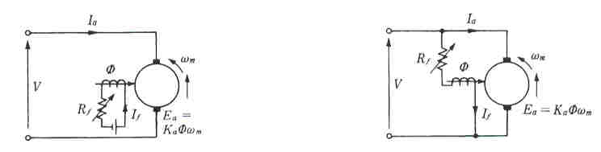
Fig. 7a Separate supply for field and armature Fig. 7b Same supply for field and armature

The following equations are used to analyze the operation of DC motor

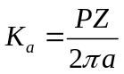 a constant
Voltage equation 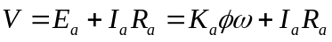
Torque equation 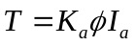
So, we can write 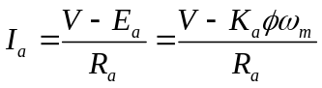
Also 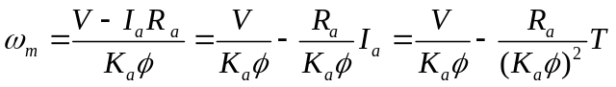
The mechanical power output is P_{m} = T ω_{m}.

So, E_{a} I_{a} = K_{a}φω_{m}I_{a} = ω_{m} K_{a}φI_{a} = ω_{m} T
So the power developed = output power.

The field flux in a DC motor is a function of field current, i.e., 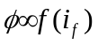 and in the separately excited motor and shunt motor, the field current is constant.

  - Starting of DC motor

While the motor is not running and suddenly the power is switched on to start the motor there will be a lot of current flow in the armature of the motor. During starting the speed of the motor ω_{m} is zero consequently there won’t be any back emf. The current during starting will be restricted by the armature resistance and is given by I_{a,st} = V/R_{a}.
Since the armature resistance is very low the starting current will be considerably high which may damage the motor. In order to restrict the starting current some external resistance is connected in series with the armature and is known as starter, the simple schemes for different motor are shown in Fig. 8. Since during normal operation the external resistance is not required the resistance are kept out of the circuit by some means.
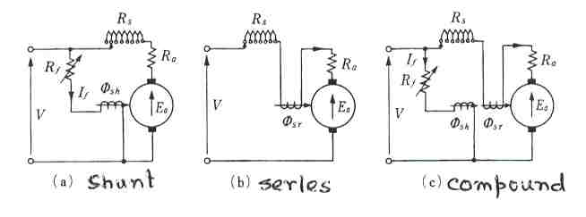
Fig. 9 Starting resistance of DC motor
3.7 DC Motor characteristics

Three main important parameters for the operation of DC motors are armature current, speed and the torque. The relationships between (i) speed-current (ii) torque-current and (iii) torque-speed are known as DC motor characteristics.
For separately excited and shunt motor the operating flux φ is considered as constant. So the characteristics for them are shown in Fig. 9. Though ideally it is assumed that the operating flux φ is constant but actually with the higher value of load current there will be demagnetization which will result in reduction of the operating value of the flux in the machine. So the actual characteristics will be as shown by the dotted line for large values of current.
For the separately excited and shunt motor, φ is constant

So, T = K_{a} φ I_{a} = K’ I_{a}, V = E + I_{a}r_{a} = K_{a} φ ω_{m} + I_{a}r_{a} = K’ω_{m} + I_{a} r_{a}.
Or, 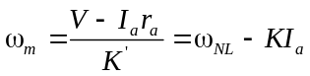.
Now for series motor the field flux is dependent on the field current as shown in Fig. 10a. For low value of field current the field flux is proportional to the field current. But due to the saturation of the magnetic circuit the field flux doesn’t follow the field current for larger value of field current. So the flux-current characteristic can be divided into two parts as shown in Fig. 10b.
If I_{a} <= I_{n}, φ = k₁ I_{a}
If I_{a} > I_{n} φ = φ_{s.}

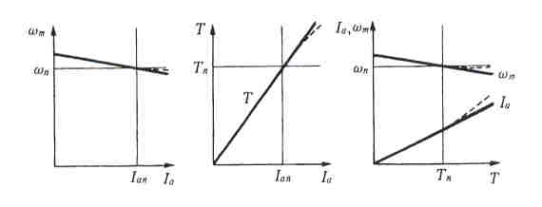

Fig. 9 Characteristics of DC shunt motor

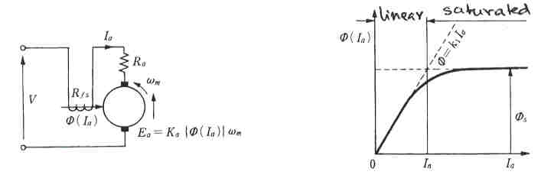

Fig. 10a DC series motor Fig. 10b Flux-current characteristic

The speed-current and speed-torque characteristics of DC series motor is shown in Fig. 11.

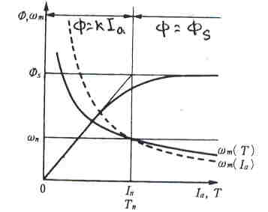

Fig. 11 Characteristics of DC series motor.

The compound motor has both the excitation from shunt field and the series field. So the characteristics of compound motor is be the combination of series motor and shunt motor and will depend on the relative flux contribution from the series field and the shunt field.

3.8 Speed control of DC motor

In different industrial applications the motors are required to run at variable speed. So it is necessary to control the operating speed of the motor. In our earlier discussion we have seen that for a specific torque the speed of the DC motor depends on armature voltage, armature resistance and the field flux. By controlling these parameters it is possible to operate the motor at variable speed. The speed-torque characteristics for different schemes are shown in Figs. 12a, b and c respectively.
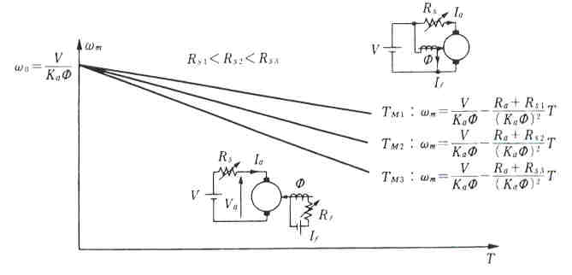

Fig. 12a Speed control through armature resistance

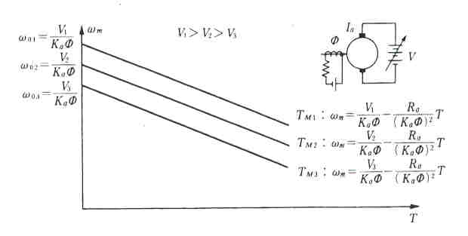

Fig. 12b Speed control through terminal voltage
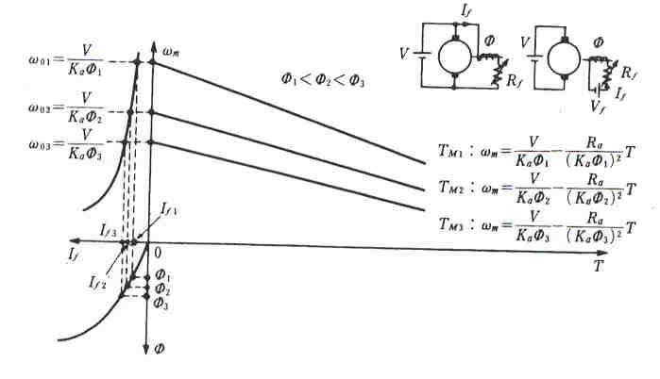

Fig. 12c Speed control through field flux

The speed control methods discussed so far are the primitive methods of speed control of DC motors. In the modern age of power electronics there are different schemes based on semiconductor devices used for the control of speed of DC motors.

3.9 Speed control of DC motor using electronic switches

The earlier section has shown that by changing the voltage across the armature it is possible to change the speed of the DC motor. Using electronic circuit it is possible to change the applied voltage across the motor terminals even though the supply voltage remains constant. In many situations it is required to control the speed of the DC motors by means of control signals emanating from microprocessors. In such cases the technique known as pulse width modulation (PWM) is generally used. Fig. 13 explain the operating principle of this scheme. This basically involves taking a constant d.c. supply voltage and chopping it so that the average values is changed. Fig. 14 shows a transistor based PWM circuit. The transistor is made on or off by applying a signal to its base. The transistor is operated either in the saturation mode or in the cut-off mode so that it behaves like an ideal switch. It is seen from Fig. 14 that a diode is required to provide a path for the current which arises when the transistor is off and the motor still carrying some current. In the absence of the diode this current will generate a very large voltage spike across the transistor terminals. Since the transistor will allow current flow only in one direction such a circuit can only be used to drive the motor in one direction.

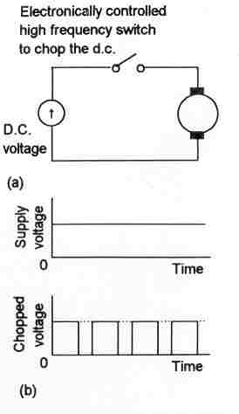
Fig. 13 Pulse Width Modulation explanation

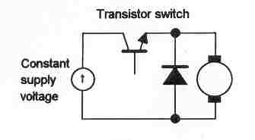
Fig. 14 Transistor aided PWM circuit

Fig. 15 shows a circuit in which four transistors are used, is termed as H-circuit or H-bridge, can be used to enable the motor to run in forward and reverse direction. This circuit can be modified with the help of logic signal to decide the direction of rotation as shown in Fig. 16.

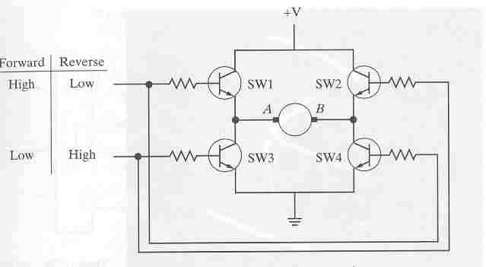

Fig. 15 H-bridge circuit
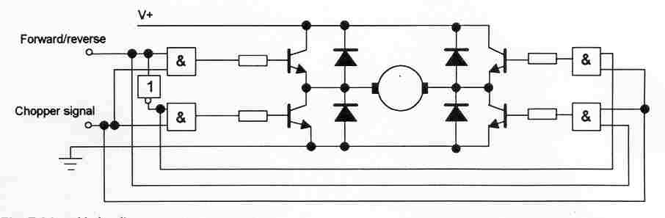
Fig. 16 H circuit with logic control

The above two circuits operate in the open loop condition i.e, no information is used from the load terminals and other operating conditions. They work very well if the supply voltage and load driven by the motor and other conditions are remaining constant. In order to suit the varying operating condition usually closed loop control is used.

3.10 Modeling of DC motor

To understand the closed loop control of DC motor the modeling (system equations) of the DC motor is discussed in this section. Usually the speed of the DC motor is controlled through armature control method. The flux is kept constant corresponding to maximum utilization of the core material. The electric circuit of the armature and the free body diagram of the rotor are shown in Fig. 17.
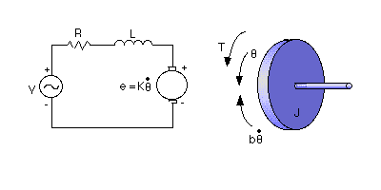
Fig. 17 Modeling of DC motor

The motor torque, T , is given by
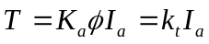 ; φ is kept constant, k_{t} is a constant and is known as armature constant.

The back emf, e, is given by
e = K_{a} φ ω = k_{e} ω ; k_{e} is a constant and is known as motor constant. Usually k_{e} is equal to k_{t}.
The electric circuit equation is given by
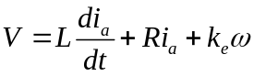
The dynamic equation of the motor under no-load condition is given by
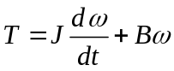 ; 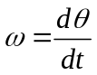
Or, 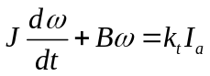

To design the control system the derivation of transfer function is important. The input of the motor is armature voltage and the output is the speed of the motor.
Taking Laplace transformation, the modeling equations written above can be expressed as
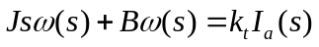
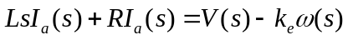
So, 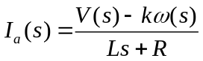 ; Assume k = k_{e} = k_{t}.
Now, 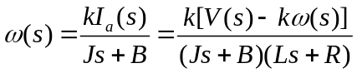
So, 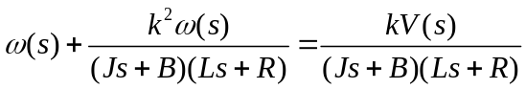
Or, 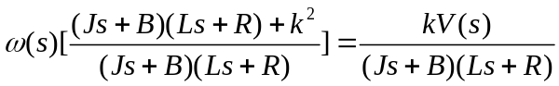
So the open loop transfer function between the speed and the armature voltage is thus given by
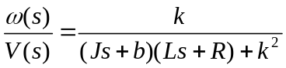.

State-space representation

The system equations can also be represented in the state-space form. The armature current and the rotational speed of the motor are taken as state variables. The voltage is the input and the rotational speed is the output.
The state space representation is given by
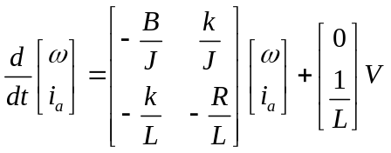
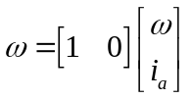

3.11 Closed loop control

Figs. 18a, b and c show different schemes for closed loop control. In Fig. 18a a tachogenerator is used to for feeding back the speed signal. This given the signal in analogue form and DAC is required to convert it into digital form and it goes to the microprocessor.
The output from the microprocessor is converted to an analogue signal by an DAC and the signal from DAC is used to vary the voltage applied to the armature of the DC motor. In Fig. 18c an encoder is used to provide the feedback signal. Since this is in the form of digital signal, ADC is not required. A code converter is used to fed the speed signal to the microprocessor.
The output from the microprocessor is exactly the same as discussed in Fig. 18a.
In Fig. 18c the output from the microprocessor is directly sent to a PWM circuit which generates the pulses for the driver circuit. This scheme is complete digital scheme.

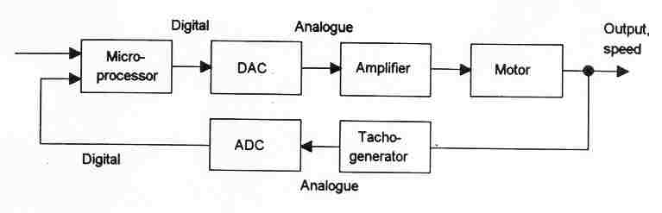
(a)

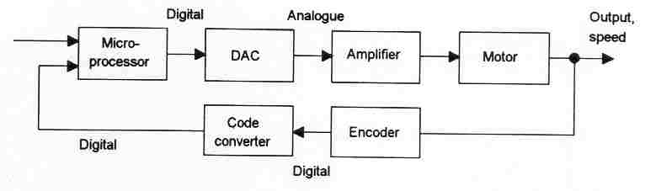
(b)

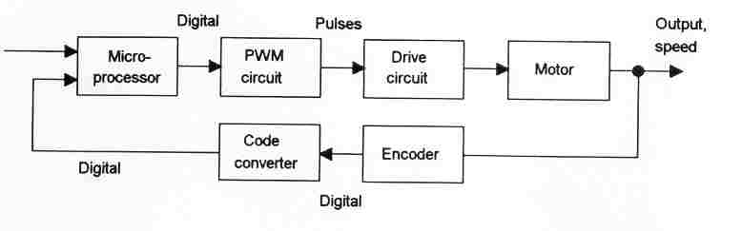
(c)
Fig. 18 Closed loop control using feedback

3.12 Brushless Permanent Magnet DC motors

The DC motors has got commutator and brushes which periodically reverse the armature current. The brushes make sliding contact with the commutator and because there is always friction between the two surfaces as shown in Fig. 19, they suffer wear. Also there is sparking at the surface due to heat and it generates high frequency signals which interfere with the nearby system. It is necessary to replace the brushes frequently and the commutator surface also need maintenance. To avoid all such problems brushless motors have been designed.

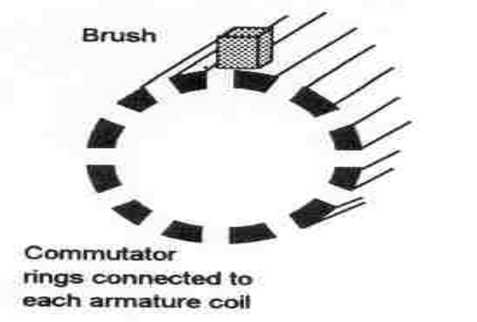
Fig. 19 Commutator

In permamnent magnet brushless DC motor the rotor is made up of permanent magnet either ferrite or ceramic material. The stator consists of a sequence of stator coils as shown in Fig. 20. So the current carrying conductor being in the stator is fixed and the magnet being in the rotor moves.
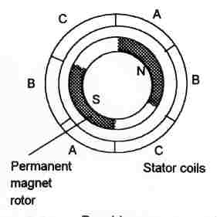
Fig. 20 Brushless permanent magnet motor

The current to the stator coils is electronically switched by transistors in sequence round the coils as shown in Fig. 21. The switching is controlled by the position of the rotor so that there are always forces acting on the magnet causing it to rotate in the same direction. Hall sensors are generally used to sense the position of the rotor and initiate the switching by the transistors, the sensors being positioned around the stator.
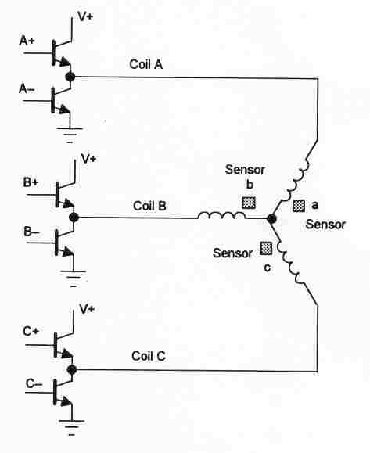
Fig. 21 Transistor switching

To switch the coils in sequence it is required to supply signals to switch the transistors on in the right sequence. Usually three sensors are used which operate through a decoder circuit to generate the appropriate base signals. The entire circuit for controlling such a motor is available on a single integrated circuit.

